PROJECT REPORT
on
Build Sphere: Gaming Hardware E-Commerce Platform with Custom PC Builder
BATCH-2024



PROJECT MENTOR STUDENT NAME & ID
Mr. Sandeep Rana 1. Ansh Srivastava (2411981094)
2. Aman Singh (2411981065)
3. Anurag Sharma (2411981103)

Sustainable Development Goals
Aligning Sustainable Development Goals (SDGs)
SDG Goal | Project Alignment
SDG 4: Quality Education | Promotes technical hardware awareness by educating users on component compatibility (CPU sockets, DDR memory types, wattage requirements) during custom PC assembly.
SDG 8: Decent Work and Economic Growth | Supports modern digital trade and e-commerce infrastructure for computer hardware micro-retailers and individual system builders.
SDG 9: Industry, Innovation, and Infrastructure | Provides a modern web platform with hardware compatibility checking to simplify custom PC building.

TABLE OF CONTENTS
Section | Sub-sections
1. Introduction | 1.1 Objective  1.2 Technology Stack
2. Project Description | Overview of Modules & Target Users
3. System Architecture & Design | 3.1 High-Level System Architecture  3.2 Detailed System Design
4. Database Design | 4.1 ER Diagram & Schema Specifications  4.2 Table Relationships
5. Data Flow Diagrams (DFD) | 5.1 Level 0 DFD (Context Diagram)  5.2 Level 1 DFD (Process Decomposition)
6. Features Implemented | Summary Table of Implemented Features
7. Screenshots | Application UI Mockups and Flow Layouts
8. Challenges Faced | Technical Challenges & Solutions
9. Pending Tasks & Future Enhancements | Remaining Work & Future Recommendations
10. Conclusion | Project Summary and Learning Outcomes
11. Appendix | Repository, Tools, and Documentation Links

1. Introduction
1.1 Objective
The objective of Build Sphere is to develop an online platform where users can purchase gaming hardware, build custom PCs, and verify hardware compatibility before placing an order. Beyond conventional e-commerce capabilities such as product catalog browsing, cart management, and order placement, Build Sphere introduces an integrated Custom PC Builder. This tool guides customers step-by-step through selecting compatible hardware components (CPU, Motherboard, RAM, GPU, SSD, Cabinet, PSU), performing automated compatibility checks, and calculating total cost before build finalization.
1.2 Technology Stack
Component Layer | Technology Choice | Functional Role
Frontend UI | React.js | Single Page Application (SPA) architecture with reusable components.
Client Routing | React Router v6 | Declarative navigation and protected route management.
HTTP Communication | Axios | Promise-based HTTP client for RESTful API calls.
UI Styling | Vanilla CSS | Custom responsive layout design and CSS styling.
Backend Runtime | Node.js | Event-driven asynchronous JavaScript runtime.
Backend Framework | Express.js | RESTful routing, middleware stack, and business logic execution.
Database Management | MySQL | Relational database schema with transactional support.
Authentication & Security | JWT & bcrypt | Token-based user authentication and salt-hashed passwords.
API Documentation/Testing | Postman | Endpoint testing, validation, and API documentation.

2. Project Description
Build Sphere organizes its functionalities into seven cohesive modules catering to two primary actor roles: Customer and Admin. The platform supports multiple hardware categories such as CPUs, GPUs, Motherboards, RAM, Storage, Cabinets, PSUs, and Gaming Accessories.
User Roles & Permissions
- Customer Role: Registration, Login, Profile access, Product Browsing with search and category filtering, Product Details inspection, Cart management, Wishlist management, Order placement, Order history tracking, Product rating/review submission, Custom PC Builder usage, and Saving PC builds.
- Admin Role: Secure Admin authentication, Product CRUD operations, Category management, Inventory/Stock management, and Global Order status tracking and updates.
Core System Modules
- Module 1 - Authentication: User registration, login, JWT token issuance, and password hashing with bcrypt.
- Module 2 - Product Management: Catalog display, dynamic filtering by category, text search, and detailed spec views.
- Module 3 - Shopping: Cart add/remove/update, Wishlist toggle, and Checkout processing.
- Module 4 - Orders: Order placement workflow, order items snapshot, status tracking (Pending, Shipped, Delivered), and historical view.
- Module 5 - Reviews: Product ratings (1 to 5 stars) and user review comments.
- Module 6 - Custom PC Builder (Main USP): Step-by-step guided selection flow (CPU -> Motherboard -> RAM -> GPU -> SSD -> Cabinet -> PSU) with validation logic for CPU Socket, DDR Memory Version, Form Factor, and PSU wattage compatibility. Automatically sums total cost.
- Module 7 - Admin Dashboard: Inventory management, category maintenance, order status moderation, and product management.

3. System Architecture & Design
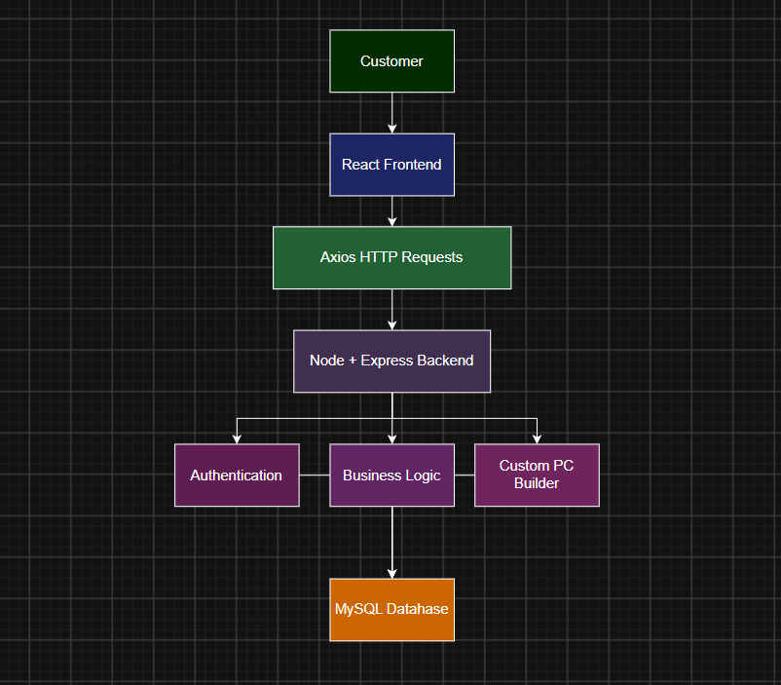
Figure: System Architecture
3.1 High-Level System Architecture
Build Sphere follows a three-tier architecture consisting of the Presentation Layer, Application Layer, and Database Layer.
- Presentation Layer (Frontend): Developed using React.js, it provides the user interface for browsing products, building custom PCs, managing the shopping cart, and placing orders.
- Application Layer (Backend): Built using Node.js and Express.js, it processes user requests, implements business logic, manages authentication using JWT, and communicates with the database.
- Database Layer: MySQL stores all application data, including users, products, orders, categories, reviews, and custom PC builds.

3.2 Detailed System Design
The backend is organized into the following layers:
- Routes – Define the API endpoints and direct requests to the appropriate controllers.
- Controllers – Handle incoming requests, validate input, and execute the required business logic.
- Middleware – Manages authentication, request processing, CORS configuration, and error handling.
- Models/Database Layer – Interacts with the MySQL database to perform CRUD operations and maintain data consistency.

4. Database Design
4.1 Database Schema & Tables
The database is designed from scratch in MySQL using 11 normalized tables with primary keys, foreign key constraints, and cascading rules. Below are the table specifications:
Table Name | Attributes & Keys
Users | user_ id (PK), name, email (Unique), password_ hash, role ('Customer'/'Admin'), phone, created_ at
Categories | category_ id (PK), category_ name, description, created_ at
Products | product_ id (PK), category_ id (FK), title, description, price, stock_ quantity, socket_ type, ddr_ type, form_ factor, wattage, created_ at
Product Images | image_ id (PK), product_ id (FK), image_ url, is_ primary
Cart | cart_ id (PK), user_ id (FK), product_ id (FK), quantity, created_ at
Wishlist | Wishlist_ id (PK), user_ id (FK), product_ id (FK), created_ at
Addresses | address_ id (PK), user_ id (FK), street, city, state, zip code, country, is_ default
Orders | order_ id (PK), user_ id (FK), address_ id (FK), total_ amount, status ('Pending'/'Shipped'/'Delivered'/'Cancelled'), created_ at
Order Items | order_ item_ id (PK), order_ id (FK), product_ id (FK), quantity, unit_ price
Reviews | review_ id (PK), user_ id (FK), product_ id (FK), rating (1-5), comment, created_ at
PC Builds | build_ id (PK), user_ id (FK), cpu_ id (FK), motherboard_ id (FK), ram_ id (FK), gpu_ id (FK), ssd_ id (FK), cabinet_ id (FK), psu_ id (FK), total_ cost, created_ at

4.2 Relationships
- One-to-Many: Users -> Orders (user_ id in Orders references user_ id in Users)
- One-to-Many: Users -> Cart (user_ id in Cart references user_ id in Users)
- One-to-Many: Users -> Wishlist (user_ id in Wishlist references user_ id in Users)
- One-to-Many: Users -> Addresses (user_ id in Addresses references user_ id in Users)
- One-to-Many: Users -> Reviews (user_ id in Reviews references user_ id in Users)
- One-to-Many: Users -> PC Builds (user_ id in PC Builds references user_ id in Users)
- One-to-Many: Categories -> Products (category_ id in Products references category_ id in Categories)
- One-to-Many: Products -> Product Images (product_ id in Product Images references product_ id in Products)
- One-to-Many: Orders -> Order Items (order_ id in Order Items references order_ id in Orders)
- Many-to-One: Order Items -> Products (product_ id in Order Items references product_ id in Products)
- Foreign Key Constraints: Defined with ON DELETE CASCADE and ON UPDATE CASCADE to maintain referential integrity.
5. Data Flow Diagrams (DFD)
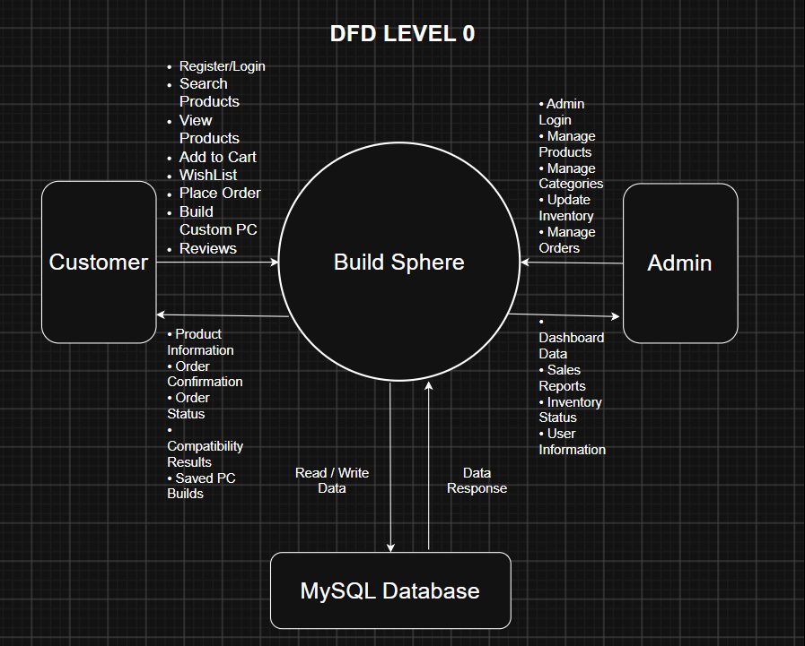
5.1 Level 0 DFD (Context Level)
5.2 Level 1 DFD (Process Decomposition)
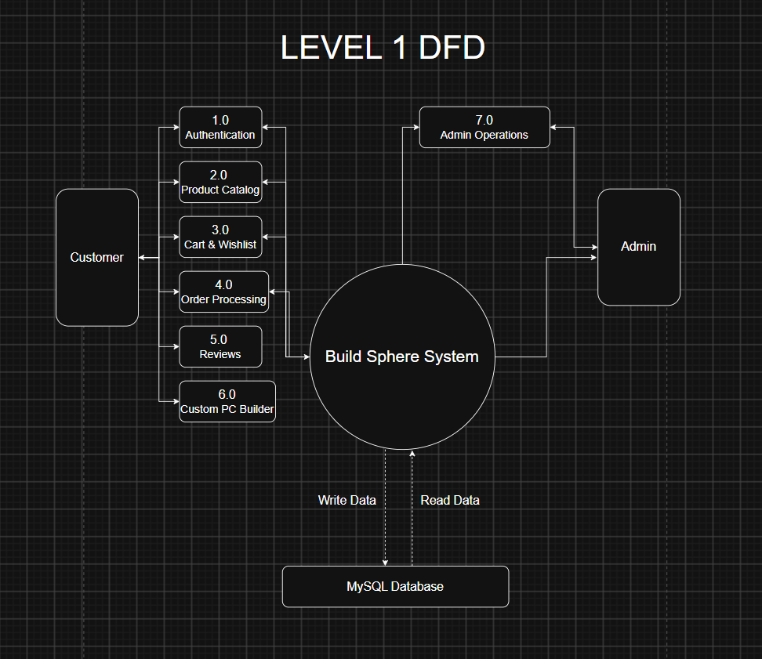
6. Features Implementation
7. Screenshots
Figure 7.1: User Authentication Interface
Figure 7.2: Homepage & Product Catalog
Figure 7.3: Product Details Page
Figure 7.4: Shopping Cart & Checkout
Figure 7.5: Custom PC Builder Interface
Figure 7.6: Admin Management Dashboard
8. Challenges Faced
9. Pending Tasks & Future Enhancements
9.1 Pending Tasks
9.2 Future Enhancements
- Integration of Payment Gateway (Razor pay / Stripe) for automated transaction handling.
- Automated Email Notifications (Node mailer) for order confirmations and shipping updates.
- Side-by-side component specification comparison tool.
- User profile invoice downloading in PDF format.

10. Conclusion
The Build Sphere platform aims to provide a full-stack gaming hardware e-commerce solution with an intelligent Custom PC Builder. Built upon a 3-tier architecture utilizing React.js, Node.js, Express.js, and MySQL, the application ensures high performance, clean modularity, and strict relational data integrity.
By incorporating compatibility validation algorithms directly into the component assembly workflow, Build Sphere solves a significant real-world problem for PC enthusiasts and hardware buyers. The project demonstrates practical mastery of REST API engineering, database normalization across 11 tables, JWT authentication, and full-stack software development practices.

11. Appendix
- GitHub Repository:
- API Documentation:
- Database Scripts:
- Course Details: Course Code: 25CS022 - Back-end Engineering | Chitkara University

